CPE301 – SPRING 2019

Design Assignment 3B

Student Name: Victor Martinez

Student #: 5003131674

Student Email: [martiv6@unlv.nevada.edu](mailto:martiv6@unlv.nevada.edu)

Primary Github address: https://github.com/martiv6

Directory: https://github.com/martiv6/submissions_da/tree/master/DesignAssignment/DA3B

Submit the following for all Labs:

1. In the document, for each task submit the modified or included code (only) with highlights and justifications of the modifications. Also, include the comments.
2. Use the previously create a Github repository with a random name (no CPE/301, Lastname, Firstname). Place all labs under the root folder ESD301/DA, sub-folder named LABXX, with one document and one video link file for each lab, place modified asm/c files named as LabXX-TYY.asm/c.
3. If multiple asm/c files or other libraries are used, create a folder LabXX-TYY and place these files inside the folder.
4. The folder should have a) Word document (see template), b) source code file(s) and other include files, c) text file with youtube video links (see template).

1. **COMPONENTS LIST AND CONNECTION BLOCK DIAGRAM w/ PINS**

Temp

sensor

FDTI

BREAD

BOARD

328P

Mini

POWERSUPPLY

1. **INITIAL/MODIFIED/DEVELOPED CODE OF TASK 1/A**

/*

* DA3A.c

*

* Created: 3/27/2019 2:47:19 PM

* Author : martiv6

*/

#define *F_CPU* 16000000UL

#define BAUD 9600

#define MYUBRR *F_CPU*/16/BAUD-1

#include <avr/io.h>

#include <util/delay.h>

#include <stdio.h>

#include <avr/interrupt.h>initializer

void read_adc(void); // where the ADC is read

void adc_initializer(void); // where ADC initializes

void USART_init( unsigned int ubrr ); // where USART initializes

void USART_tx_string(char *data); // where it print string USART

volatile unsigned int room_temp; // where we store the temp of the ADC

char outs[35]; // room we have to print

int main(void)

{

adc_initializer(); // Initialize the ADC (Analog / Digital Converter)

USART_init(MYUBRR); // Initialize the USART (RS232 interface)

USART_tx_string("Connected!\r\n"); // shows theres a connection with USART

*_delay_ms*(125); // waits

sei(); // enable global interrupts

while(1) // waits for interrupt

{

}

}

void adc_initializer(void)

{

ADMUX = (0<<REFS1)| // Reference Selection Bits

(1<<REFS0)| // AVCC- external cap at AREF

(0<<ADLAR)| // ADC Left Adjust Result

(1<<MUX2)| // Analog Channel Selection Bits

(0<<MUX1)| // PC5 is where its monitoring

(1<<MUX0);

ADCSRA = (1<<ADEN)| // ADC enabled

(0<<ADSC)| // ADC start conversion

(0<<ADATE)| // ADC auto trigger enable

(0<<ADIF)| // ADC interrupt flag

(0<<ADIE)| // ADC interrupt enable

(1<<ADPS2)| // ADC prescaler select bits

(0<<ADPS1)| // ADC prescaler select bits

(1<<ADPS0); // ADC input

// Timer/Counter1 Interrupt Mask Register

TIMSK1 |= (1<<TOIE1); // enable overflow interrupt

TCCR1B |= (1<<CS12)|(1<<CS10); // clock

TCNT1 = 49911; //((16MHz/1024)*1)-1 = 15624

}

void read_adc(void) // initialize to begin to read from the sensor

{

unsigned char i =4; // to keep track of input

room_temp = 0;

while (i--)

{

ADCSRA |= (1<<ADSC); // used to start convo with chips

while(ADCSRA & (1<<ADSC));

room_temp+= ADC;

*_delay_ms*(50);

}

room_temp = room_temp/8 ; // gets correct value displayed

}

/* INIT USART (RS-232) */

void USART_init( unsigned int ubrr )

{

UBRR0H = (unsigned char)(ubrr>>8);

UBRR0L = (unsigned char)ubrr;

UCSR0B = (1 << TXEN0); // Enable receiver, transmitter & RX interrupt

UCSR0C = (3 << UCSZ00); // asynchronous 8 N 1

}

void USART_tx_string( char *data ) // used to print on to the screen

{

while ((*data != '\0'))

{

while (!(UCSR0A & (1 <<UDRE0)));

UDR0 = *data;

data++;

}

}

ISR(TIMER1_OVF_vect) // timer overflow interrupt to delay for 1 second

{

read_adc(); // read ADC

*snprintf*(outs,sizeof(outs),"%3d F \r\n", room_temp); // prints it

USART_tx_string(outs); // prints spaces

TCNT1 = 49911; // reset tcnt value for delay

}

1. **DEVELOPED MODIFIED CODE OF TASK 2/A from TASK 1/A**

**n/a**

1. **SCHEMATICS**

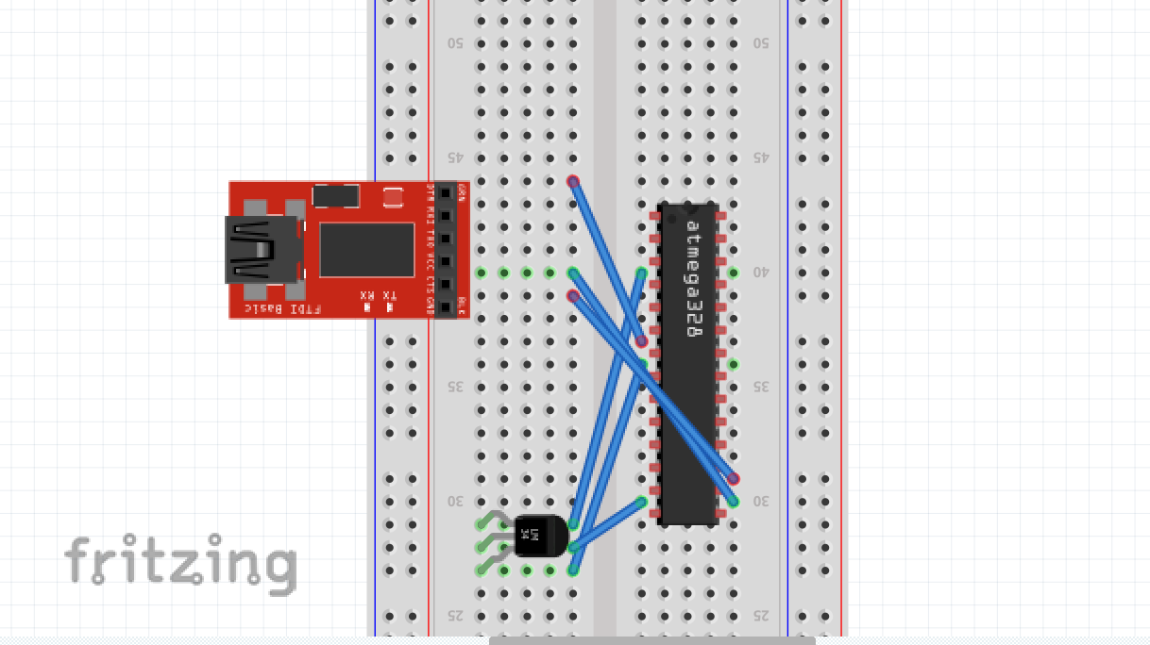

1. **SCREENSHOTS OF EACH TASK OUTPUT (ATMEL STUDIO OUTPUT)**

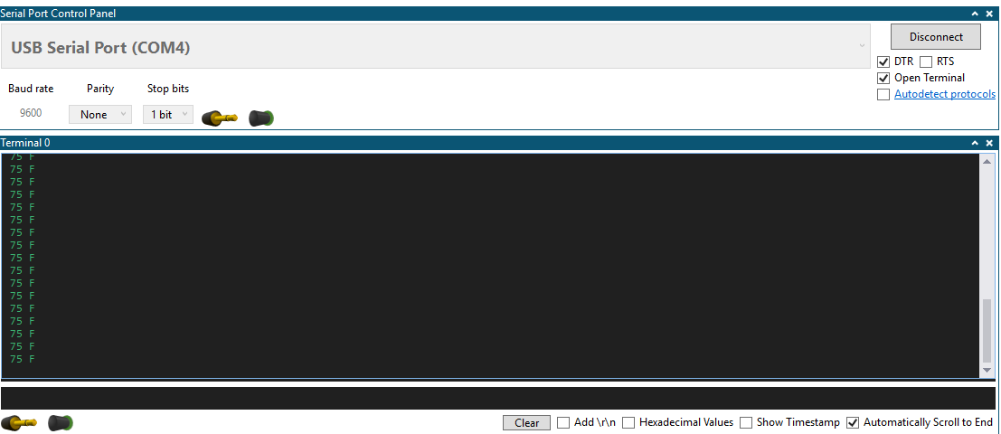

1. **SCREENSHOT OF EACH DEMO (BOARD SETUP)**

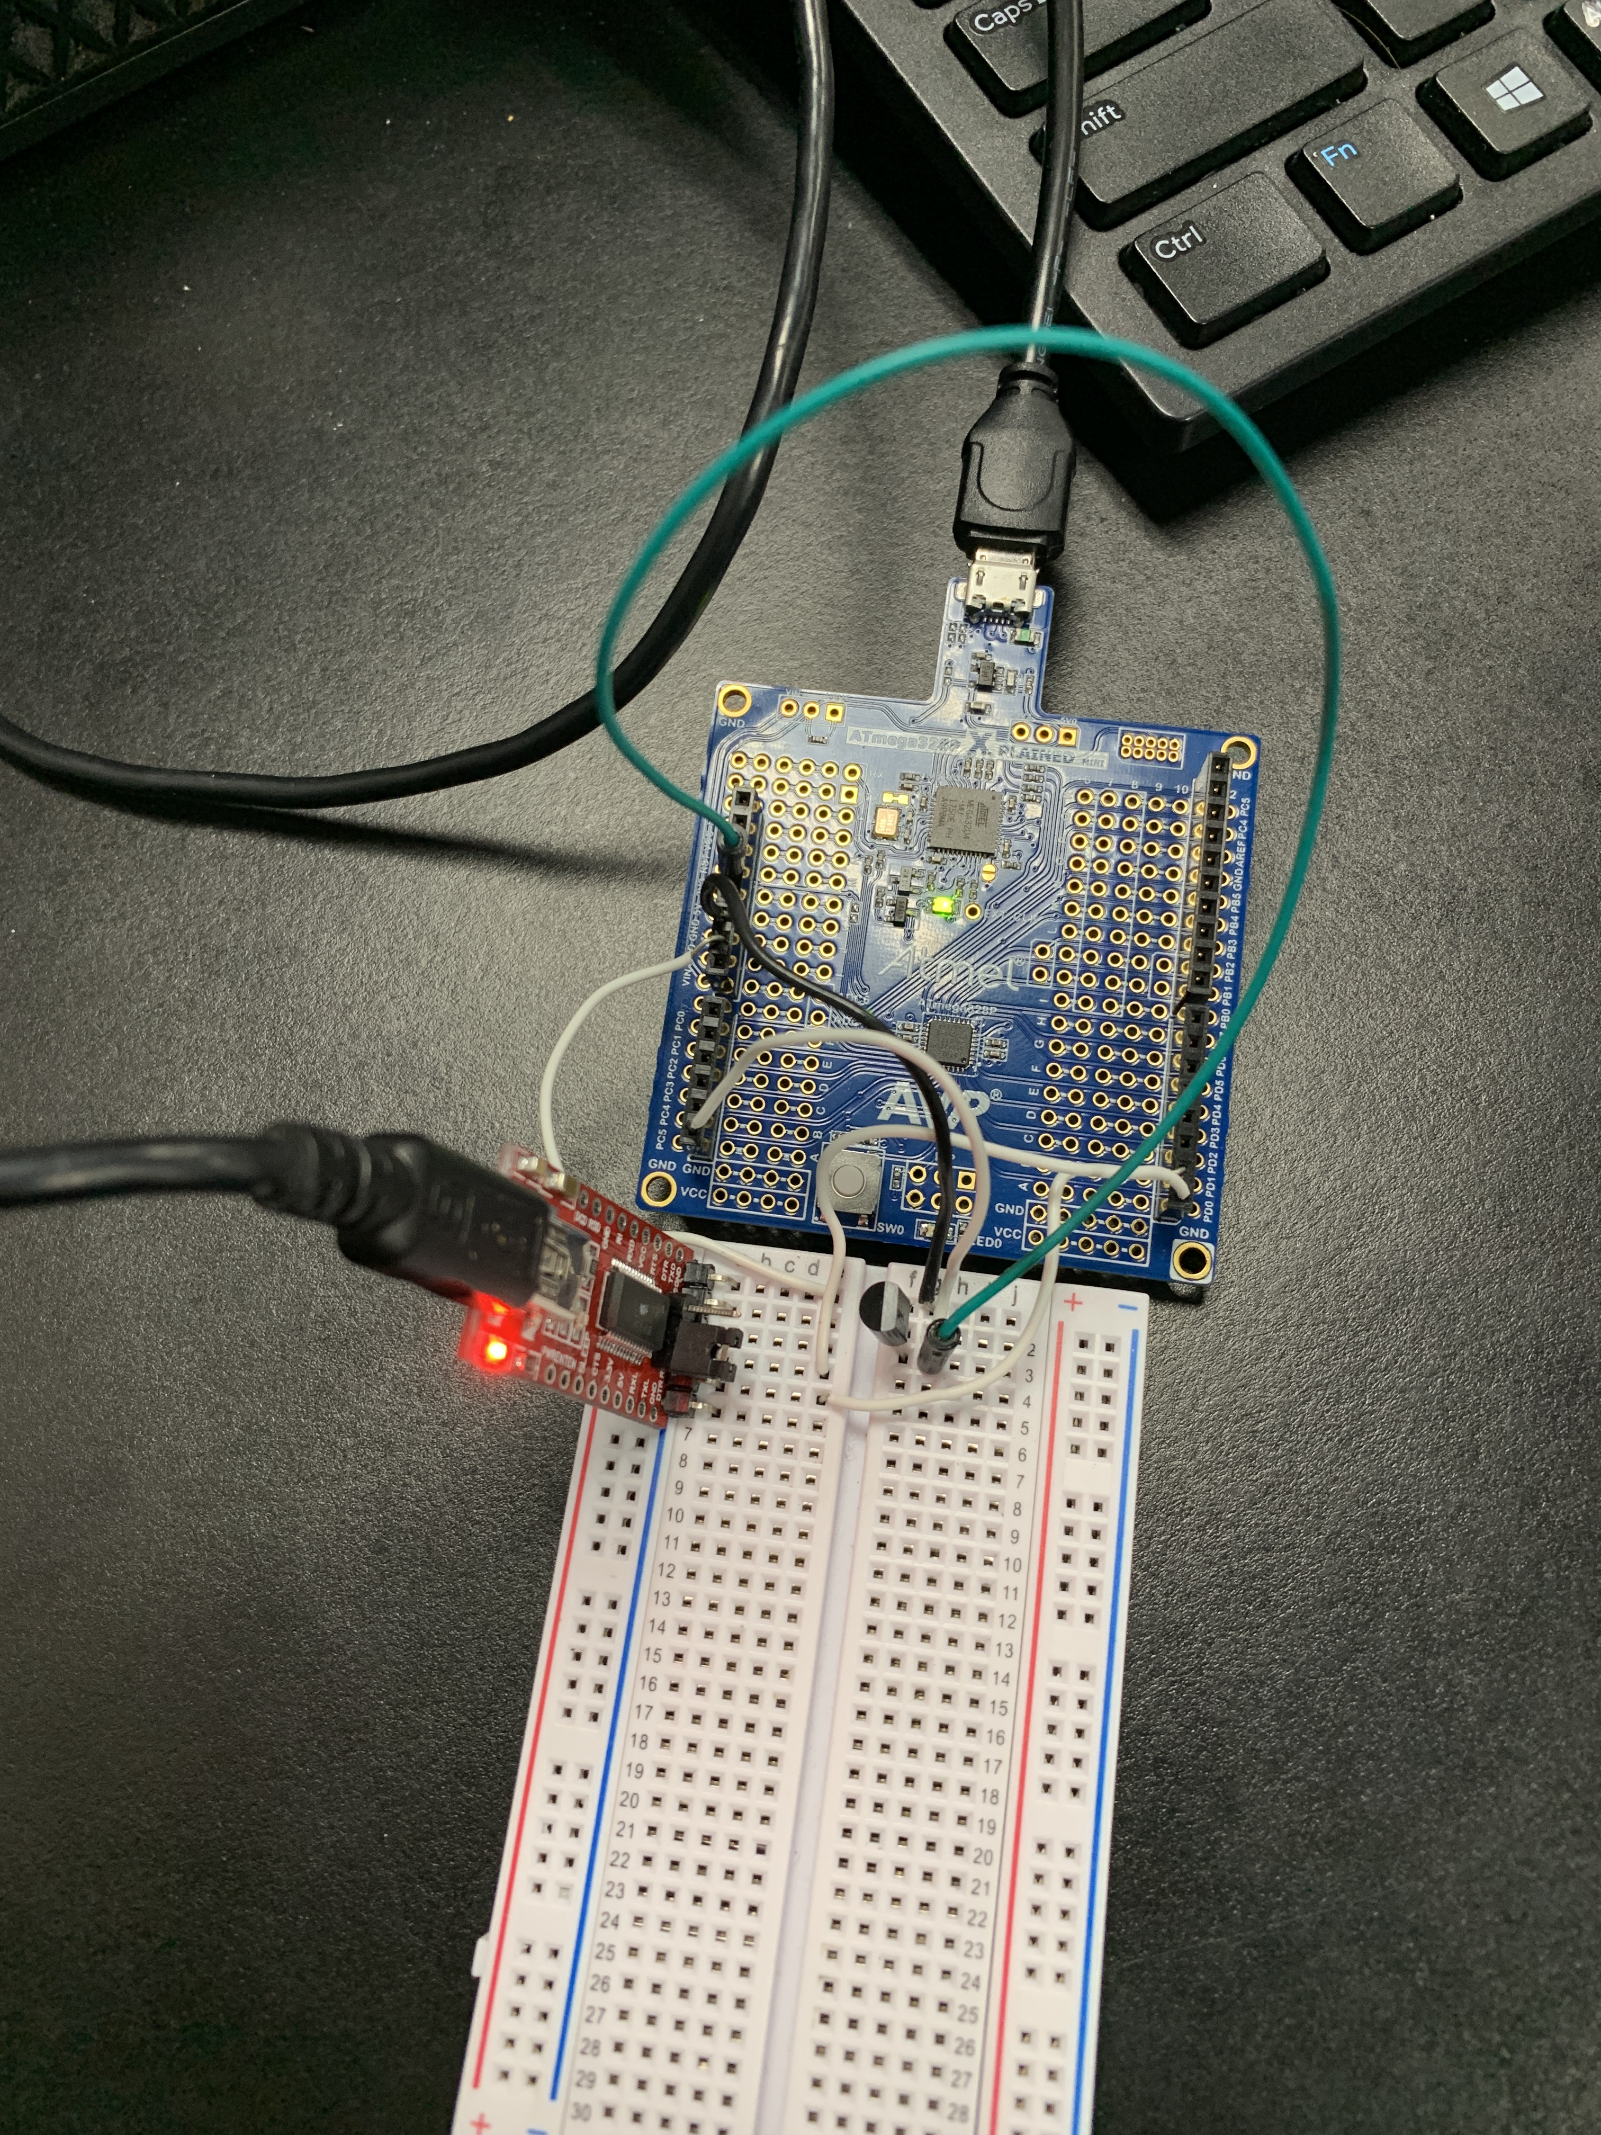

1. **VIDEO LINKS OF EACH DEMO**

[**https://youtu.be/eBIiI0rIVps**](https://youtu.be/eBIiI0rIVps)

**8. GITHUB LINK OF THIS DA**

<https://github.com/martiv6/submissions_da/tree/master/DesignAssignment/DA3>B

**Student Academic Misconduct Policy**

<http://studentconduct.unlv.edu/misconduct/policy.html>

“This assignment submission is my own, original work”.

VICTOR MARTINEZ